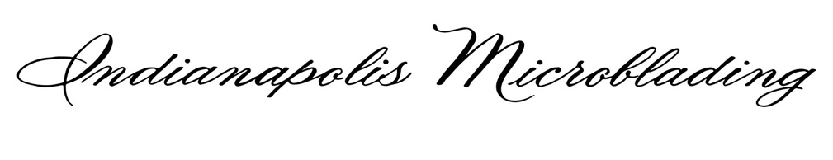
COVID -19 CLIENT CONSENT / RECENT HEALTH HISTORY
I ______________________ (name) understand that I am opting for an elective treatment.
I also understand that the novel coronavirus, COVID-19, has been declared a worldwide pandemic by the World Health Organization. I further understand that COVID-19 is extremely contagious and is believed to spread by person-to-person contact; and, as a result, federal and state health agencies recommend social distancing. I recognize that Indianapolis Microblading artists are closely monitoring this situation and have put in place reasonable preventative measures aimed to reduce the spread of COVID-19. However, given the nature of the virus, I understand there is an inherent risk of becoming infected with COVID-19 by virtue of proceeding with this elective treatment. I hereby acknowledge and assume the risk of becoming infected with COVID-19 through this elective treatment, and I give my permission for Indianapolis Microblading and all artists to proceed with the treatment at no liability to them.
I understand that, even if I have been tested for COVID and received a negative test result, the tests in some cases may fail to detect the virus or I may have contracted COVID after the test. I understand that, if I have a COVID-19 infection.
I understand that possible exposure to COVID-19 before/during/after my treatment may result in the following: a positive COVID-19 diagnosis, extended quarantine/self-isolation, additional tests, hospitalization that may require medical therapy, Intensive Care treatment, possible need for intubation/ventilator support, short-term or long-term intubation, other potential complications, and the risk of death. ______
I understand that COVID-19 may cause additional risks, some or many of which may not currently be known at this time. _____
I know that the CDC recommends social distancing of at least 6 feet and that Marion County has allowed for businesses to reopen despite that information. ______

I understand the COVID-19 virus has a long incubation period during which carriers of the virus may not show symptoms and still be highly contagious. It is impossible to determine who has it, and who does not give the current limits in virus testing. _________
I understand that air travel significantly increases my risk of contracting and transmitting the COVID-19 virus and if I have been on airplane within 30 days my appointment will need to be rescheduled (including touch up). ________
I have not had any symptoms including fever, shortness of breath, loss of taste, loss of smell, cough, runny nose, sore throat within the past 30 days. ______
I have been or not had close known contact with anyone who has tested COVID-19 positive within the past 30 days. _______
For healthcare workers, please be aware you may not wear soiled scrubs into the facility and please try and schedule for evening appointments if able. _____
I understand certain medical conditions and older age increase my risks and to help decrease any possible exposure I should ask my artist about morning appointments. _____
To prevent the spread of the COVID-19 virus and to help protect each other, I understand that I will have to follow Indianapolis Microblading's guidelines. ____
I will be required to wear a mask during the procedure excluding lipblush/facial/facial waxing. _____
I should wear hair pulled back (if it is long enough). ______
No guests accompanying appointment (unless medically necessary). _____
I agree to have touchless temperature taken and recorded by artists, and if it is 99.5 degrees or higher, I will have to reschedule appointment. _______
If I have had a COVID-19 vaccination or planning on getting one, appointment should be made 2 weeks prior to or 2 weeks after. _______
I will disclose with the owner/artist if within 2 weeks of appointment I develop any illness symptoms concerning of COVID-19. I will also disclose if I get a test performed and the results. _______
I understand all the potential risks, including but not limited to the potential short-term and long-term complications related to COVID-19, and I would like to proceed with my desired treatment. ____

Signature / Date

